Assignment 9

Q1. WAJP to design a method to pass int type value and print it.

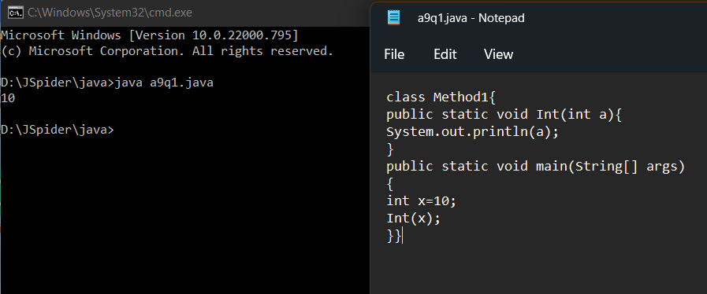

Q2. WAJP to design a method to perform multiplication with two variables.

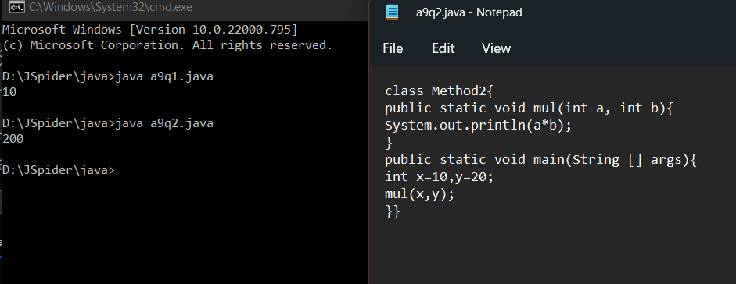

Q3. WAJP to design a method to do addition and division with only two variables.

